HATHERLEIGH YOUTH AFC & NORTH DEVON YOUTH LEAGUE (sponsored by West Country Cleaning)
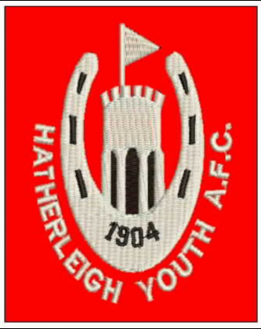
PLAYER REGISTRATION FORM 2017-2018 SEASON
ALL PARTIES, including parents, must understand that, by signing this form, they agree to abide by all FA RULES, and that fair play and good behaviour are the main objectives, as set down by the FA RESPECT Campaign.
The Club & League are Charter Standard which requires all players, parents, spectators and Club officials to adhere to the FA RESPECT Codes of Conduct as issued to all clubs, players, coaches, spectators, parents & carers.
ANY PERSON knowingly supplying FALSE information may find that they face a lengthy ban issued by the FA and may result in the team losing points!!
..................................................................................................................................................................
HATHERLEIGH YOUTH AFC PLAYER’S NAME ...................................................................
AGE GROUP; U/....... DATE OF BIRTH .................................... YEAR @ SCHOOL …………
FULL ADDRESS ………………………………...............................................................................
……………………………….......................................................
…………………………………....................................................
POSTCODE ……………………………………………………………….…
EMAIL ADDRESS …………………………………………………………………………………………………….
NAME & MOBILE; ………………………………………………….………………………………………………
ADDITIONAL NAME & CONTACT NUMBER; ……………………….………………………………………….
MEDICAL ISSUES/CONDITIONS/ALLERGIES .......................................................................................................................
PLAYERS MAY ONLY REGISTER AND PLAY FOR ONE TEAM AND CANNOT PLAY IN MORE THAN ONE AGE GROUP.
In signing this form, I understand that I acknowledge to follow the rules laid down by the FA & its RESPECT campaign. I confirm that I/my child have read & understood the codes of conduct supplied & will abide by their terms. Harmful or derogatory comments that may cause offence to the league, club, it’s players, coaches, helpers or opponents on any form of social media will not be accepted.
PLAYER’S SIGNATURE ……………................................... PARENT/GUARDIAN SIGNATURE ……………………………....................
MANAGER’S SIGNATURE; Andy Bennett PLAYERS FAN NUMBER (on ID CARD) …………………………………………………
Please make the club aware if either of the following affect your child; Photo’s & film may be used in various forms of media (ie. Newspapers, facebook, website, or for training purposes). FA 1st aid qualified coaches & carers associated with the club may administer treatment.
................................................................................................................................................................
For League use only; Player registration Number ................

